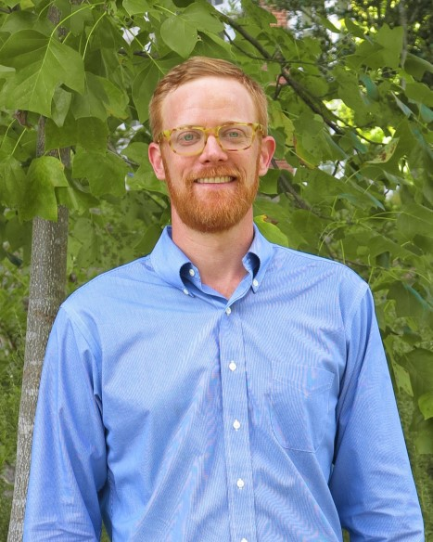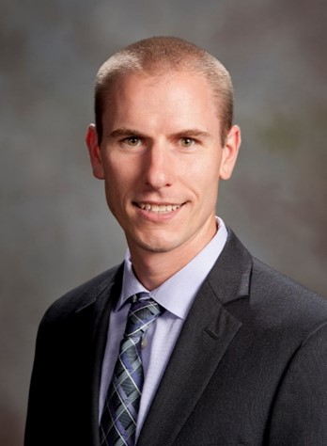
Member-at-Large—Academia
Nicholas T. Basinger
Dr. Nicholas T. Basinger is an Assistant professor in the Department of Crop and Soil Sciences at the University of Georgia where he joined in 2018. He received his MS and Ph.D. degrees from North Carolina State University under the direction of Drs. Katie Jennings and David Monks where he worked on weed management in perennial fruit
crops and annual vegetable crops. He maintains an active Weed Ecology/Biology and Integrated Weed Management research and teaching program that includes students
across the University of Georgia’s three campuses in Athens, Tifton, and Griffin. Nick’s goal as an instructor is to provide opportunities for students to think critically and apply their knowledge to real world scenarios. In his teaching role, Nick has reached 178 stu- dents since 2018 through teaching graduate and undergraduate courses in Weed Science, Weed Technology, and Herbicide Physiology. He also serves as the Coach for the UGA Weed Team and is passionate about sharing his love of weed science with students.
In his research role, he is interested in crop/weed interactions and integrated weed management approaches through the use of cover cropping, intercropping, and living mulches in corn, soybean, cotton, and canola. He is also interested in the effects of altering the agroecosystems on weed demography. He is also investigating the biology, ecology, and con- trol of Setaria parviflora, an emerging pasture/hayfield weed in the mid-south. He has formed interdisciplinary teams of soil scientists, weed scientists, and climate scientists to both gain further understanding of the agroecosystems in which he and his team work, and to maximize the impact of his team’s research. Nick has presented over 40 abstracts
at the SWSS, WSSA, and other academic meetings and authored 14 peer-reviewed articles and 1 book chapter.
Dr. Basinger has been a member of SWSS since 2014 where he joined as a graduate student. He was selected as the SWSS Outstanding Graduate Student in 2018 and has remained active in the SWSS where he has served as member and Chair of the SWSS Outstanding Graduate Student committee and has served as a judge for both the student oral and poster contests. He has chaired the American Society of Agronomy Weedy and Invasive Species Community and
is a Board Member for the Southern Cover Crops Council. He looks forward to continuing his service to the SWSS in a great capacity as a member-at-large.
Michael Flessner
Dr. Michael L Flessner is an associate professor and extension weed science specialist in the School of Plant and Environmental Sciences at Virginia Tech. He received his BS from the University of Tennessee. He obtained both his masters and doctoral degrees from Auburn Uni- versity where he also served as research associated.
Michael has research and extension responsibilities for weed management in corn, soybean, small grains, and other crops as well as pastures and forages across Virginia. His research ef- forts focus on herbicides and herbicide resistance as well as cover crops and harvest weed seed control. To date, Michael is an author of 46 peer-reviewed publications in scientific journals, over 160 abstracts presented at professional meetings, and 19 extension publications. He has been awarded over $2 million in competitive funds to his program. Michael has advised or co- advised 8 graduate students and currently chairs or serves on 9 student committees. Michael’s students have won numerous scholarships and awards, notably enjoying success in the Society’s annual weed contest.
Michael has been a member of SWSS since 2008 and served the Society in various rolls including committee service on the Weed Resistance and Technology Stewardship, Endowment Foundation, Local Arrangements, and Resolutions and Necrology committees as well as oral/poster contest judge and section chair. Michael has served on the executive com- mittee of the Northeastern Weed Science Society (NEWSS) as Editor, in addition to other service. Michael was awarded NEWSS’s Outstanding Researcher Award in 2019. He is also involved in WSSA, currently serving on the Weed Loss
and Extension committees. Michael resides in Blacksburg, Virginia with his wife Chelsea Flessner and their two chil-
dern, Davidson and Everett.

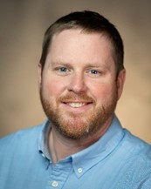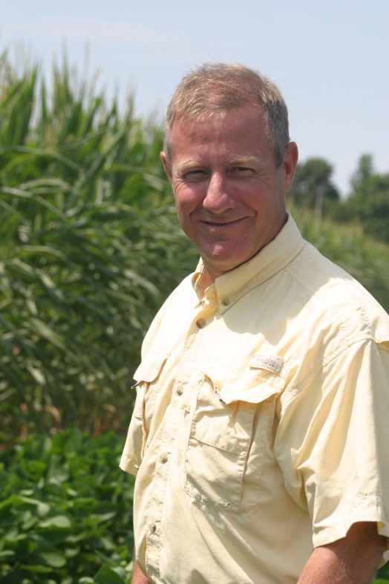
Member-at-Large—Industry
Pete Eure
Pete Eure is a Technical Product Lead for soybean and cereal herbicides at Syngenta Crop Protection. A native of eastern North Carolina, he was born and raised on a family farm where they grow corn, wheat, and soybeans. Pete received his B.S. and M.S. degrees from North
Carolina State University and Ph.D. in Weed Science from the University of Georgia where he conducted research in cotton, peanuts, and vegetables.
Pete began his career at Syngenta in 2014 as a Research & Development Scientist in Texas where his responsibilities included the screening of early-stage herbicides, insecticides, and fungicides as well as conducting product concept evaluations. In his current role, Pete manag- es the development of new weed management concepts for soybeans and cereals and supports currently registered herbicides in these crops.
Since joining the SWSS in 2010, Pete has served the Society as a graduate student contest judge, session moderator at annual meetings, a weed contest judge, chair of the graduate student paper/poster contest and chair of the agronomic crops session. Pete serves as a reviewer for Weed Technology and is a member of WSSA where he serves on the Pro- fessional Development and Membership Committee. He currently lives in Greensboro, North Carolina with his wife Tabitha.
K. Bruce Kirksey
Bruce Kirksey is the Director of Farm and Research at Agricenter International in Mem- phis, TN where he manages the farm and conducts field research trials on 1000 acres. He works with all segments of the agriculture industry as he establishes product develop- ment, variety testing, and new crop interests on corn, cotton, soybeans, wheat, rice, and other crops.
In his career, he has been involved in research and development with several companies and has over 30 years of experience in experimental trials. Kirksey has a B.S. in Agricul- ture from the University of Tennessee at Martin and a M.S. and Ph.D. in Plant and Soil Science from the University of Tennessee at Knoxville. Bruce started his career with Sandoz Agro and was product development specialist in North and South Dakota. From there, Bruce worked for BASF in product development and moved around with BASF. He worked in North Carolina, Washington state and Mississippi. Bruce then went to work for Stoneville Pedigreed Seed in Memphis, TN. Bruce then worked for Winfield, a Land O’Lakes Company where he was the Answer Plot coordinator for the south.
Bruce then went to work for Agricenter International as Director of Research in 2009. Kirksey is active in presenting papers at research conferences and is involved in many pro-
fessional organizations such as the Weed Science Society of America, Southern Weed Science Society, National Cotton Council, American Seed Trade Association, Mississippi Seedmen’s Association, Southern Seed Association, Tennes- see Agricultural Production Association, and the Memphis Agricultural Club. His research focuses on agronomic practices of southern crops, organic interests, and specialty crops. Bruce and his wife Marsha live on a farm in Pinson, TN.

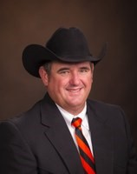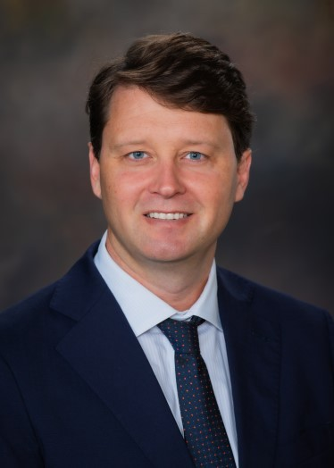
Vice President—Academia
Todd Baughman
Todd Baughman is a native of southwestern Oklahoma. He received his B.S. and M.S. in Agronomy from Oklahoma State University, and his Ph.D. in Weed Science from Mississippi State University. Todd currently serves as a Professor and Weed Scientist at Oklahoma State University.
Prior to coming to OSU, he served as a Professor, Extension Agronomist, and State Extension Peanut Specialist with Texas A&M University; and as a Product Development Representative with Sandoz Agro, Inc. covering the V-C Region. Todd is responsible for conducting research and providing educational information useful to producers for weed management in summer
cropping systems.
He has authored or co-authored 44 journal articles, 225 abstracts, 123 technical articles, 77
press releases, and 4 plant material releases. Todd has served as chair or member on 18 graduate student committees. He has been an active member of the Southern Weed Science Society since 1990. As a student, he participated and placed in the SWSS Student Paper and Poster Contests and the Southern Weed Contests. Todd has served on the SWSS board as a Member-At-Large (Academia) and as Secretary-Treasurer. He served on the Student Program Com-
mittee for 9 years and as the chairperson of that committee three different times, and as a contest judge for many years. He has also served as a local arrangements chair, program section chair, and chair or member of numerous other SWSS committees. He was honored as the SWSS Outstanding Young Weed Scientist by the society in 2006. Todd has served as a reviewer and Associate Editor for Weed Science and is currently serving on the WSSA Finance and Science Policy Committees. He has also served as the President of the American Peanut Research and Education Soci- ety and is recognized as a Fellow of APRES.
Scott McElroy
Scott McElroy is a Professor in the Department of Crop, Soil, and Environmental Sciences at Auburn University. Dr. McElroy currently holds a distinguished Alumni Professorship as se- lected by the Auburn University Alumni Association. He received his MS from Auburn Uni- versity and his PhD from the NC State University in Crop Science with a minor in Plant Ecolo- gy. Dr. McElroy now holds a joint appointment at Auburn University with the Alabama Agri- cultural Experiment Station and the College of Agriculture. His primary research areas are on methods for weed management in turfgrass systems, and physiology and molecular biology of herbicide resistant weed species. He is an associate editor for the Weed Science Society of America Journal, Weed Technology, and also serves as a reviewer for Weed Science, Agrono- my Journal, and Pest Management Science, among others. Dr. McElroy teaches three classes, Principles of Weed Science (CSES 3120), Applied Weed Science Technology (CSES 5200/6200), and Advanced Turfgrass Management (CSES 5120/6120). Dr. McElroy main-
tains an active international research and teaching presence previously serving as an elected board member for the Eu- ropean Turfgrass Society. Dr. McElroy was awarded the Director’s Research Award from the College of Agriculture at Auburn in 2009, the Outstanding Young Weed Scientist Award in 2011 from the Southern Weed Science Society,
and the 2013 Early Career Weed Scientist Award from the Weed Science Society of America.
Dr. McElroy was born and raised in Moulton, Alabama, a small town in Northwest Alabama. In his youth, Dr. McElroy was an avid basketball player, signing a basketball scholarship with Northwest Community College in Phil
Campbell, Alabama for his freshman year and transferring his sophomore year to play at Calhoun Community College in Decatur, Alabama. Dr. McElroy is married to Dr. Nichole McElroy, DVM. They have three children, Joseph (17), William (15) and Trent (13). In his spare time, Dr. McElroy is a member of the Auburn Masters Swimming Team, plays golf (very badly), and attempts to avoid mowing his own lawn at all costs.

Te-Ming “Paul” Tsing
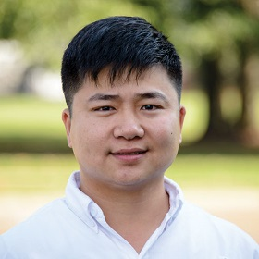Dr. Te-Ming “Paul” Tseng is an Associate Professor in the Department of Plant and Soil Sciences at Mississippi State University. He received his B.S. in Biotechnology from Bangalore University, India, and his M.S. in Plant Biotechnology from Allahabad Agricultural Institute, India. He obtained his Ph.D. in Cell & Molecular Biology in Weed Science from the University of Arkansas, Fayetteville. Following his Ph.D., he worked as a postdoctoral research associate at the University of Arkansas and Purdue University.
He is currently working on identifying herbicide-resistant mechanisms in numerous weed species and characterizing competitive traits in weeds to understand the genes and/or biochemical pathways associated with these competitive traits. Courses taught are “Weed Biology and Ecology,” “Herbicide Physiology and Biochemistry,” and “Environmental Fate of Herbicides.” He has advised and successfully graduated 6 Doctoral and 4 Master's students. Currently, he is advising 3 Doctoral and 1 Master's student and has been on 5 Doctoral and 7 Master's committees.
Dr. Tseng has authored or co-authored 48 peer-reviewed journal articles, 4 book chapters, and 131 conference proceedings (104 in national/regional weed science proceedings). He serves as an active reviewer of federal and state grants, including the USDA AMS, USDA NIFA, MS NASA EPSCoR, Southern SARE, and Foundation for Food and Agriculture Research. He is also on the Editorial Board of Weed Science, Crop Science, Plant Gene (Elsevier), and Frontiers in Plant Science.
Dr. Tseng is very active in service to the weed science community, having been chosen for several leadership roles within the Weed Science Society of America (WSSA), Southern Weed Science Society (SWSS), and the International Weed Science Society (IWSS). Dr. Tseng currently serves as the Editor of the SWSS Proceedings, the Treasurer of the IWSS, and the WSSA representative to the Technical Advisory Group for Biological Control Agents of Weeds (a USDA APHIS unit). He has also served as a Member of the WSSA Graduate Student Travel Award Selection Committee, WSSA Undergraduate Research Award Selection Committee, WSSA Noxious, and Invasive Weeds and Biocontrol Committee, WSSA Website Committee, WSSA Professional Development and Membership Committee, WSSA Travel Enrichment Experience Committee, and SWSS Finance Committee. He chaired the WSSA Physiology Session, WSSA Soil and Environmental Aspects Session, WSSA Teaching and Extension Session, and SWSS Physiological and Biological Aspect of Weed Control.
Dr. Tseng is an active member of the Southern Weed Science Society and Weed Science Society of America and has been involved in SWSS/WSSA meetings since 2008. He has been married to Sally and is blessed with one son and one daughter.
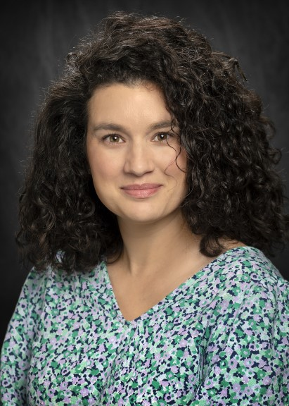Lauren Lazaro
Dr. Lauren Lazaro obtained her B.S. degree in Biology at Sweet Briar College in 2009 and her M.Sc. and Ph.D. in Plant Biology, with an emphasis in Weed Ecology, from Southern Illinois University. She went on to be a Post-Doctoral Research Associate at the University of Arkansas in 2015. In 2017 Lauren joined Louisiana State University (LSU) AgCenter in the School of Plant, Environmental, and Soil Sciences where she is currently an Assistant Professor of Weed Science/Agronomy with responsibilities in
teaching and research. Lauren currently teaches three course offerings at LSU AgCenter in field crop production, introductory weed science, and field plot tech- niques. She currently mentors several undergraduate students and chairs 2 M.Sc. stu- dents and 3 Ph.D. students.

Lauren’s research focus is in integrated weed management, harvest weed seed control, and weed biology and ecology pertaining to herbicide resistant weed species. Lauren has authored 26 journal articles and one book chapter. She was awarded the Outstanding Paper in Weed Science during 2015 and currently serves on the WSSA Board of Directors as the secretary, chairs the WSSA Website Development Committee, and serves as a committee member of the WSSA Publications Board Committee. At LSU AgCenter, Lauren is the Crop Science undergraduate advisor, chair of the School of Plant, Environmental, and Soil Sciences Undergradu- ate Courses Curriculum Committee, and serves on the Scholarship Committee. Further, she is a Faculty Sen- ate member, serves on the Inter-institutional Biological and Recombinant DNA Safety Committee, and serves on the GROW executive board. Outside of academia, Lauren is a pen pal in the Letters to a Pre-
Scientist program.

Endowment Foundation—Board of Trustees

